Legend for Status:

• WV - Tropical Wave

• TD - Tropical Depression

• TS - Tropical Storm

• HU - Hurricane

• EX - Extratropical cyclone

• SD - Subtropical depression (winds <34 kt)

• SS - Subtropical storm (winds >34 kt)

• LO - A low pressure system not fitting any of above descriptions

• DB - non-tropical Disturbance not having a closed circulation

a. Find the correlation between the following variables and capture the

screenshots of your graph plots. Report on the type of relationship you observe

and indicate outliers if any:

i. Maximum Wind vs Minimum Pressure

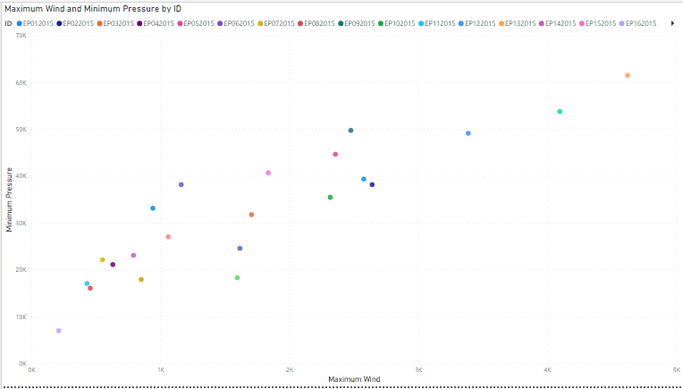

Positive correlation

ii. Low Wind NE vs Moderate Win SE

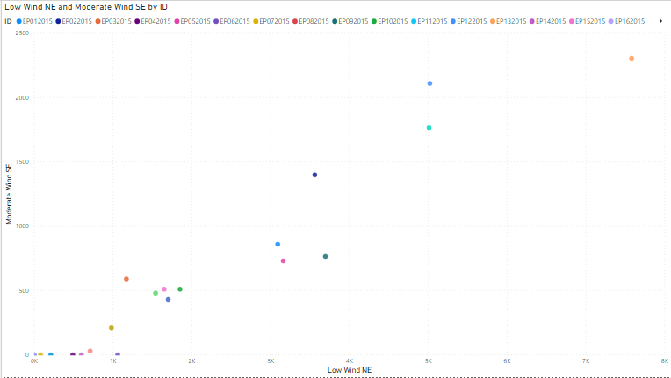

Positive correlation

iii. Maximum Wind vs Time

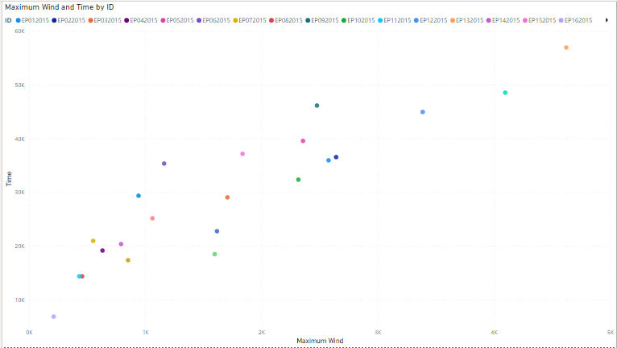

Positive correlation

iv. High Wind SE vs Low Wind NW

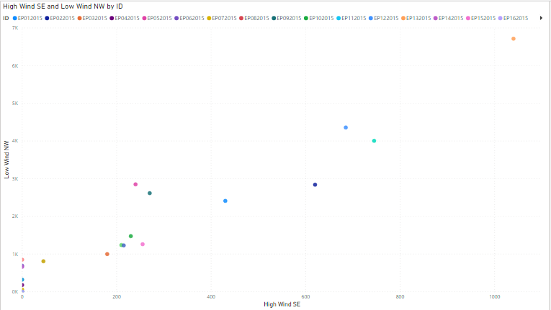

Positive correlation

b. Find the correlation between the 2 event conditions, Tropical Storm (TS) and

Hurricane (HU) with Maximum Wind and Minimum Pressure. Print the

screenshot of the display. When do Maximum Wind and Minimum Pressure

reach the peak?

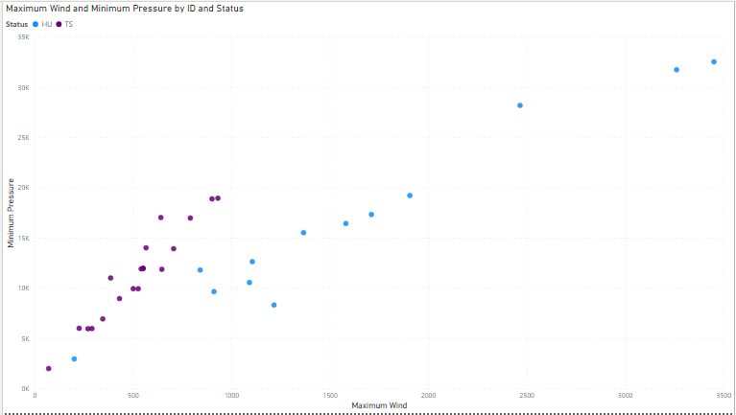

Maximum wind: 3450

Minimum pressure: 32557